12/11/2024 DSA DAY 3

- ANAGRAM:
PROGRAM:
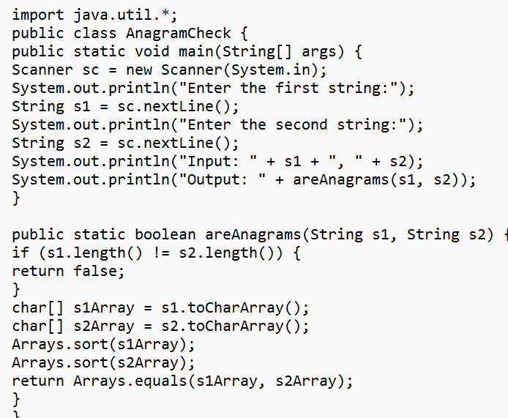
OUTPUT:
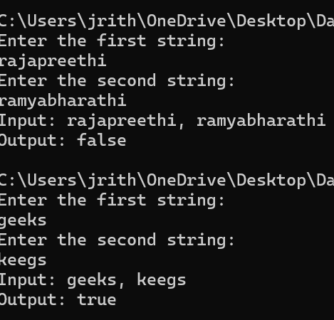
TIME COMPLEXITY: O(n)

- ROW WITH MAX 1’s
PROGRAM:
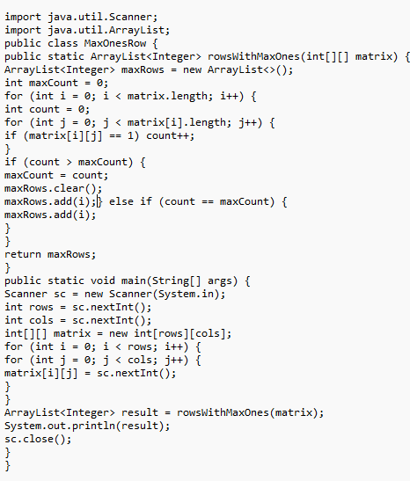
OUTPUT:
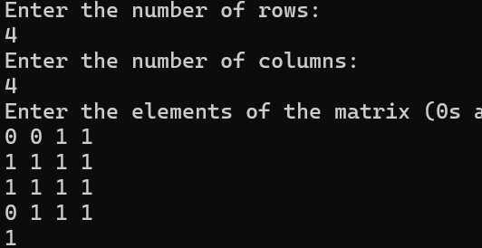
TIME COMPLEXITY: O(n*m)

- LONGEST CONSECUTIVE SUBSEQUENT

PROGRAM:
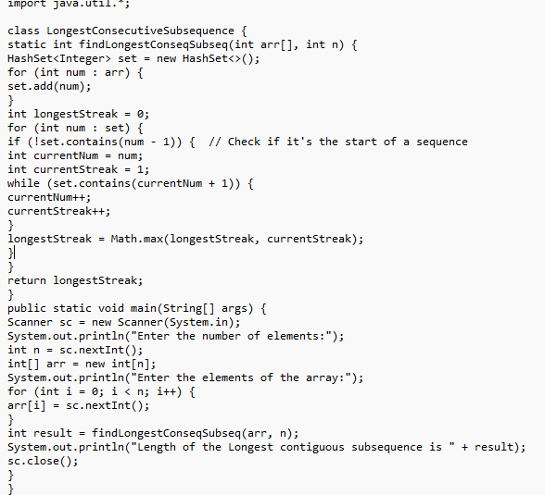
OUTPUT:
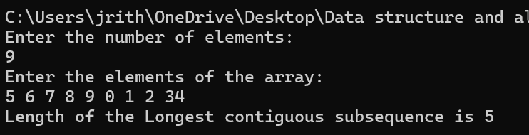
TIME COMPLEXITY: O(n)

- LONGEST PALINDROME IN A STRING
PROGRAM:
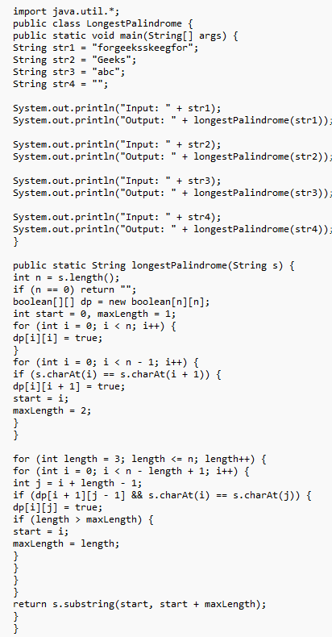
OUTPUT:
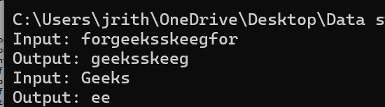
TIME COMPLEXITY: O(n^2)

- RAT IN A MAZE
PROGRAM:
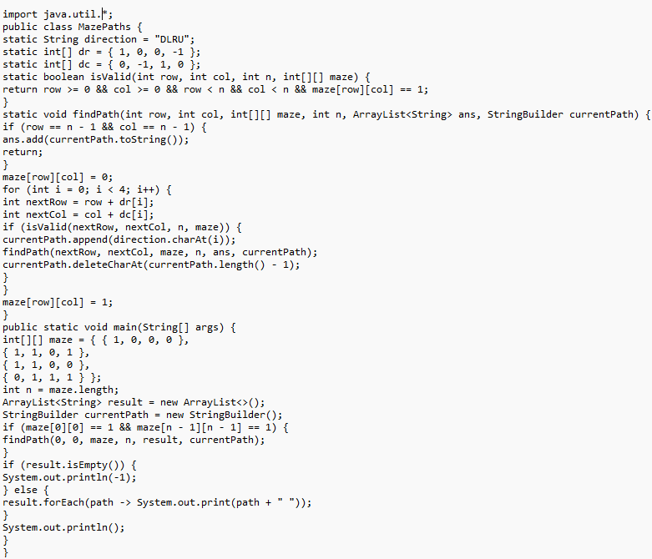
OUTPUT:
